

Colegio Tecnológico Pulmahue

TERCERO MEDIO
Name:
El objetivo de esta guía es que los estudiantes comprendan la importancia de la seguridad vial e identifiquen información relacionada en textos.

Para dudas que tengan pueden escribirme un correo a esta dirección: yorka.sepulveda.pulmahue@gmail.com, escribiendo en el asunto el nombre de él o la estudiante y su curso, el horario para correos es de 9am a 7pm. Cualquier consulta sobre los contenidos y asignatura será respondida y también en caso de que necesiten material extra.

O.A: comprender importancia de la seguridad vial como conductores y peatones
O.A2: Identificar información en textos.

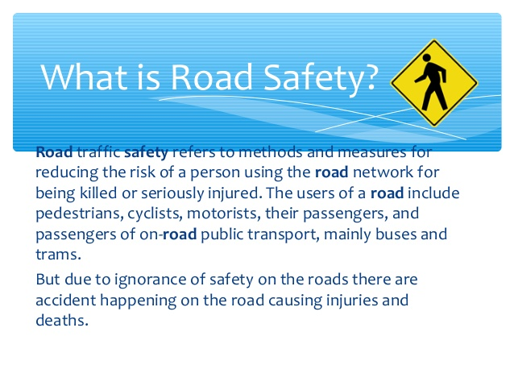

Search for other definitions of road safety, write here, use a dictionary definition or your own words.
ROAD SAFETY:

There is an event in many countries that is called road safety week, in this event many subjects related to road safety are taught and learnt.

Now we will read about the road safety week of last year, you have to identify information related to road safety and the reading in general.

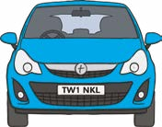


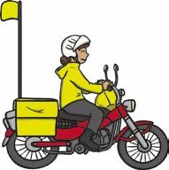
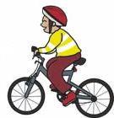

Road Safety
Road Safety Week happens every year. This year it is happening on 19th – 25th November. The theme of Road Safety Week this year is ‘Bike Smart’.

What Does ‘Bike Smart’ Mean?
This year, Road Safety Week wants people to think about staying safe when riding a bicycle or motorcycle as well as making other drivers aware of them.
Every year, lots of cyclists or motorcyclists are hurt on the roads.
Staying Safe
To stay safe, cyclists should:
- Always wear a helmet.
- Wear bright colored clothes so they can be seen in the dark.
- Use lights on their bike in the dark.
- Use hand signals to show another road
users what they will do.
- Make sure their bike is working properly and set up correctly for them.

Other Drivers
Road Safety Week wants car drivers to look carefully for people on bicycles or motorcycles. They also need to make sure they give cyclists lots of space on the road.

